FROM : STEPHANOS CHILDREN HOME, INDIA
NAME : Hathoichong Chongloi
DATE OF BIRTH/AGE : 10th May 2013
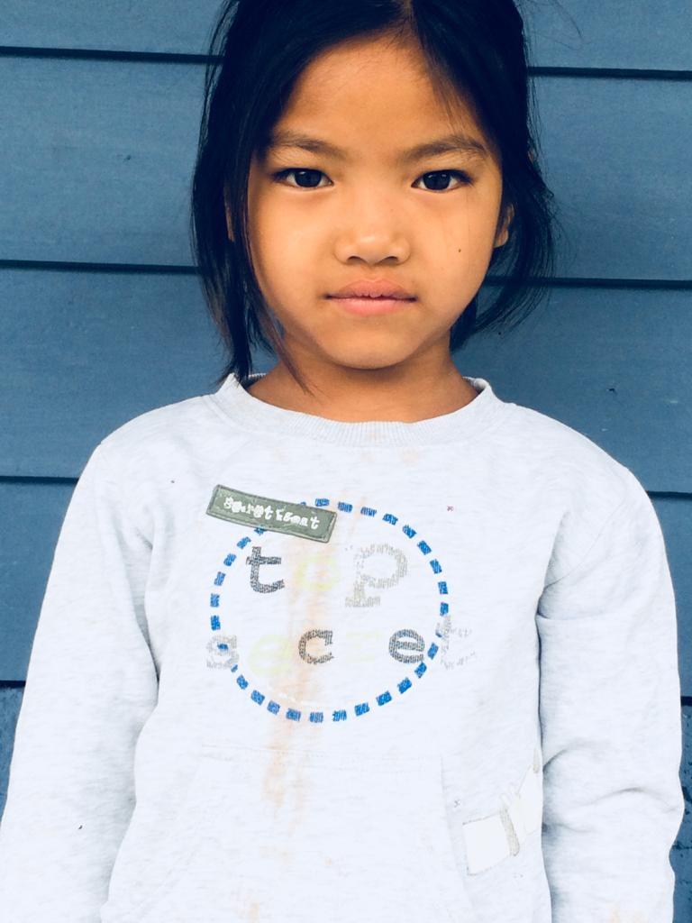
Miss Hathoichong comes from a remote village called C.Kholen in Manipur, India. She is from a very poor family. She is the youngest of five siblings. Unfortunately, her father left the family for good in the year 2014 and she has never seen her father in real life. Her mother also returned back to her paternal home. She is an intelligent girl and has certain interests however since both the parents are not present in her life, she was brought to Stephanos Children Home in Feb 2020 where she is given proper education, fooding and shelter. She loves to sing and her aim in life is to become a Nurse.

