FROM : STEPHANOS CHILDREN HOME, INDIA
NAME : Nengdeikim Hangshing
DATE OF BIRTH/AGE : 29/11/08
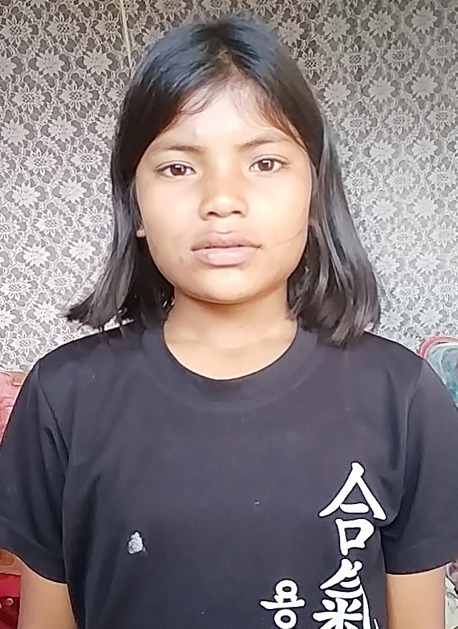

Miss Nengdeikim is the 6th daughter of Late. Thangchon Hangshing. She is from a remote village called Old Thengjang. Unfortunately, her father passed away in the year 2018. Her mother could not support her with her education due to extreme poverty. Wanting a better and brighter future for her child, she brought her to Stephanos children home in 2020. Her hobby is dancing and her aim in life is to become a Doctor.

