FROM: STEPHANOS HOME, INDIA
NAME: LAMJOYHAO HANGSHING
DATE OF BIRTH: 11-06-2011
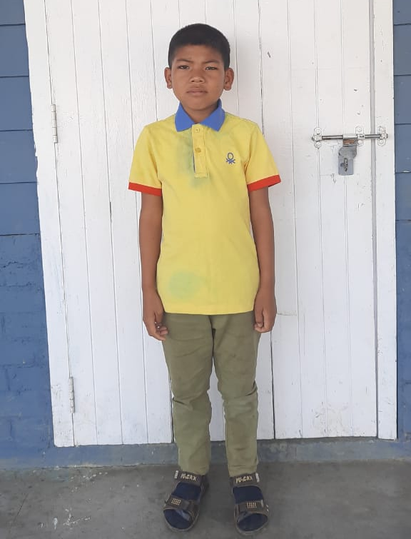

Lamjoyhao is the youngest son of Late. Thangchon Hangshing of Thenjang village. He is from a poor background family. His father passed away in the year 2018. As his mom cannot support him financially for his studies, he was brought to Stephanos Home in the year 2012 where he is provided with education spiritually, mentally & physically. His aim in life is to become an IPS officer. His hobby is playing outdoor games.

