FROM: STEPHANOS CHILDREN HOME, INDIA
NAME: SATKHOLAL GUITE
DATE OF BIRTH: 20TH MARCH 2009
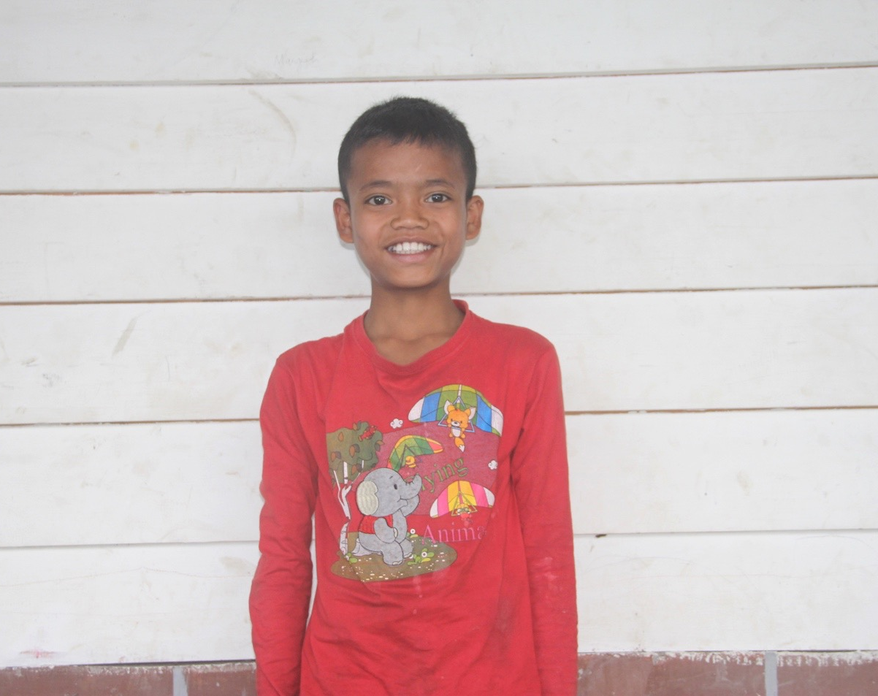

Lal is the son of late Ngamkhojam Guite. His father and mother died when he was very young and he did not even know their names. He was brought up by their grandparents. His grandparents could not support him physically and spiritually so, he was brought to Stephanos Children Home in 2016. His hobby is playing football. His aim in life is to become a police officer. He needs your love and support.

