FROM: STEPHANOS CHILDREN HOME, INDIA
NAME: KAMGOUMANG KHONGSAI
DATE OF BIRTH: 8TH MAY, 2012
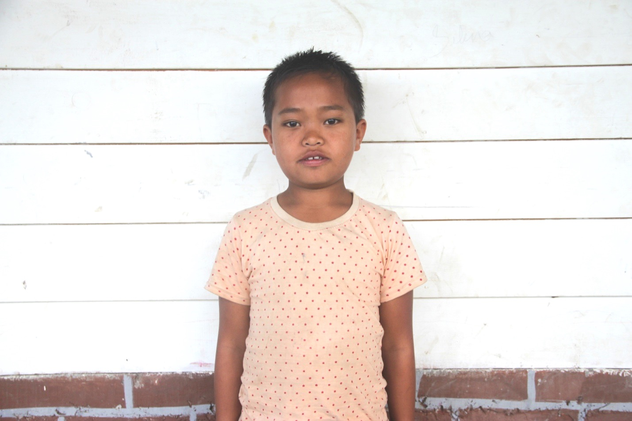

Gou is the oldest son of Paogin Khongsai. He is from a remote village Songtun Kangpokpi District Manipur. He is from a poor family. He has 4 brothers. His father was physically disabled. So, it became a big difficulty for the father to look after the Children. Therefore, seeing all the problems and difficulties Kamgoumang Khongsai has been put in Stephanos Children Home. His hobby is playing football and his aim in life is to become a Police officer. He needs your love & support.

