FROM: STEPHANOS HOME, INDIA
NAME: LHINGKHANCHING HAOKIP
DATE OF BIRTH: 08-07-2013
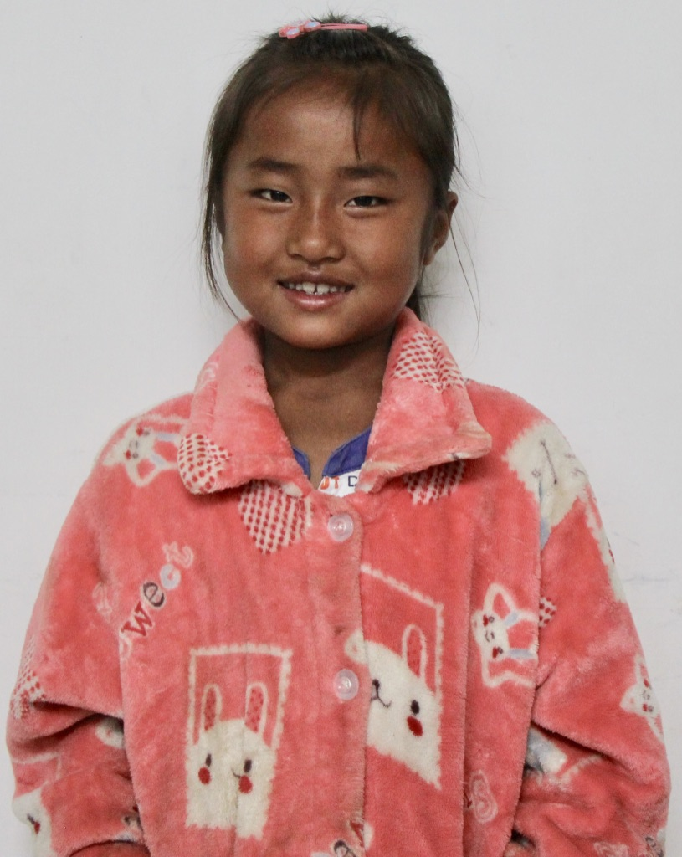

Miss Lhingkhanching was born on Jul-08-2013 at Chassad Village in Manipur, India. Her parents are infected with HIV virus and has worked very hard to support their children despite their illness. As there are four children in the family the parents struggled to support them with education with the mere income from their daily wages. It was not sufficient to meet the daily needs of their children & education. With the passage of time, the father who is HIV positive could not work anymore due to prolong illness and the mother got married to another man leaving all her children behind. Since Ching and her younger brother were not infected with the virus, their father who is lying on his ailing bed wanted a proper & bright future for his children so, with the help of their aunt, they approached “The Stephenos Home” which is a Non-Profit Orphanage Home for children so that Miss Lhingkhanching could get a proper upbringing and education in the path of God.
The home accepted the request made by their father along with the recommendation from their pastor. Now, both Ching and her brother are currently under the care of The Stephenos Home, Ch Ebenezer Leimakhong. She needs your love, prayer & support for her daily life & Education.

