FROM: BETHESDA NURSING COLLEGE, MANIPUR
N AME: Gangmei Carmela
DATE OF BIRTH: 15-12-2003
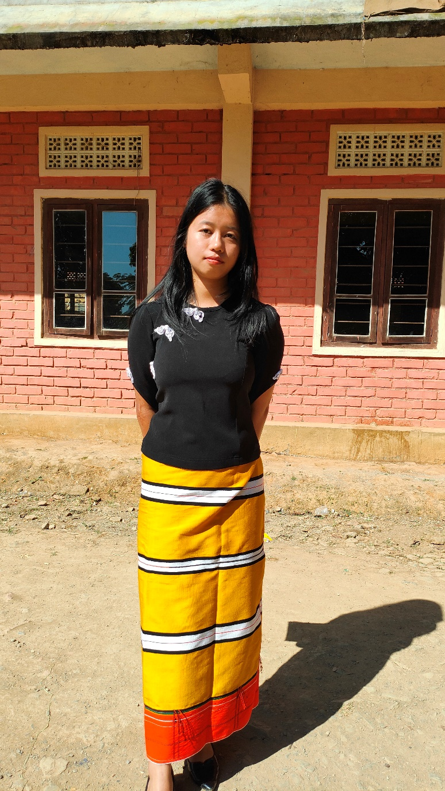

Gangmei Carmella comes from a small hilly village in Manipur. Her father died due to Jaundice when she was 15yrs old. Her widow mother run the family with much hardship. Her mother work as a sweeper in one private school with a minimum income that could hardly meet the family needs.
As Carmila desire to do her nursing studies hoping that her mother somehow will be able to support her fees. But with the mere income her mother find it so hard to support her fully. Now Carmila is in her Bsc nursing (second year). She is bright in study. Now she is in difficulties as her mother could not pay her fees. It is her desire that if she could complete her course she can work among her tribe to help the poor.

