FROM: RAINBOW HOUSE, NEPAL
NAME: KRIPA
DATE OF BIRTH: NOV, 5 2002
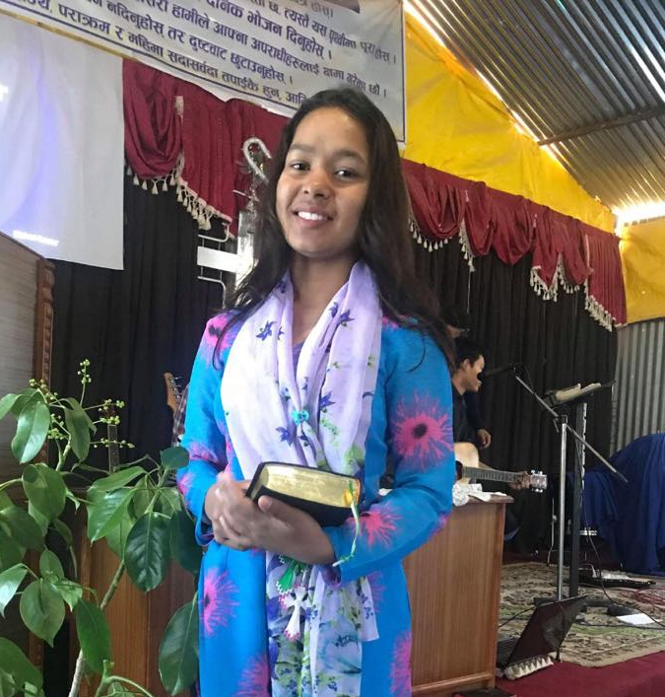

Kripa is from another mountainous district in Nepal. Her parents are blind. She came to Rainbow house when she was 3 years old. She has never met any of her relatives. Her ambition is to be a doctor. Right now, she is preparing for her 10th grade. She needs your prayer & support.

