FROM: AMAZING GRACE HOME, INDIA
NAME: CHARIS JOY CHIINTHIANBEL
DOB: 20th June 2009
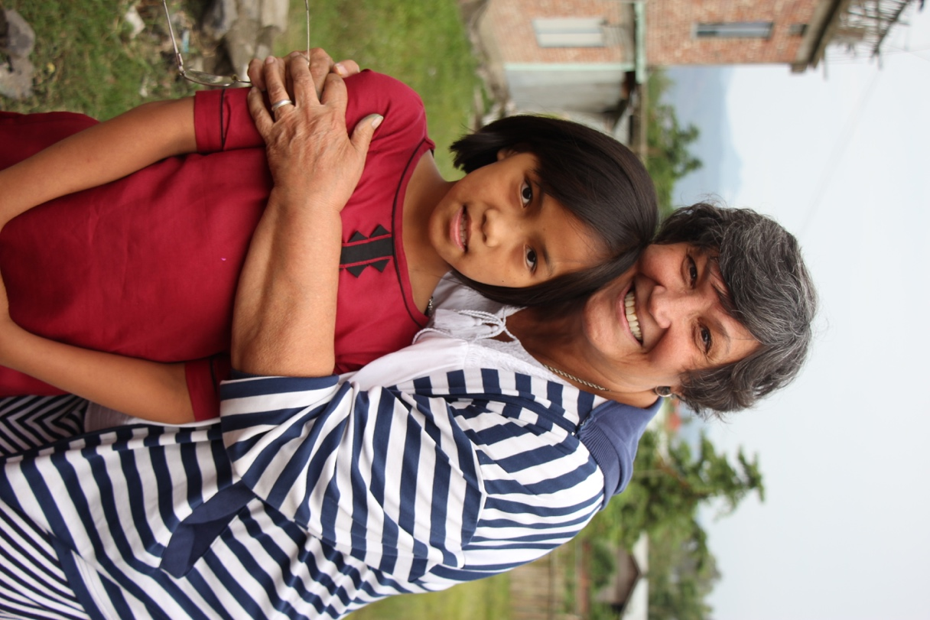

Charis Joy Chiinthianbel was taken to Amazing Grace Babies Home on 5th Feb. 2011. After she was born her mother had a boyfriend, and her father was killed by mother and her boyfriend. Her mother is convicted to prison for life.
Charis was then neglected by her family, tortured, improperly fed and emotionally disturbed. She is scared to look at adults face because of the torment. But with the love and acceptance given at the home, she in now learning to feel accepted and secure.

