FROM: STEPHANOS CHILDREN HOME, INDIA
NAME: LHINGPINENG CHONGLOI
DATE OF BIRTH: 5TH FEBRUARY 2009
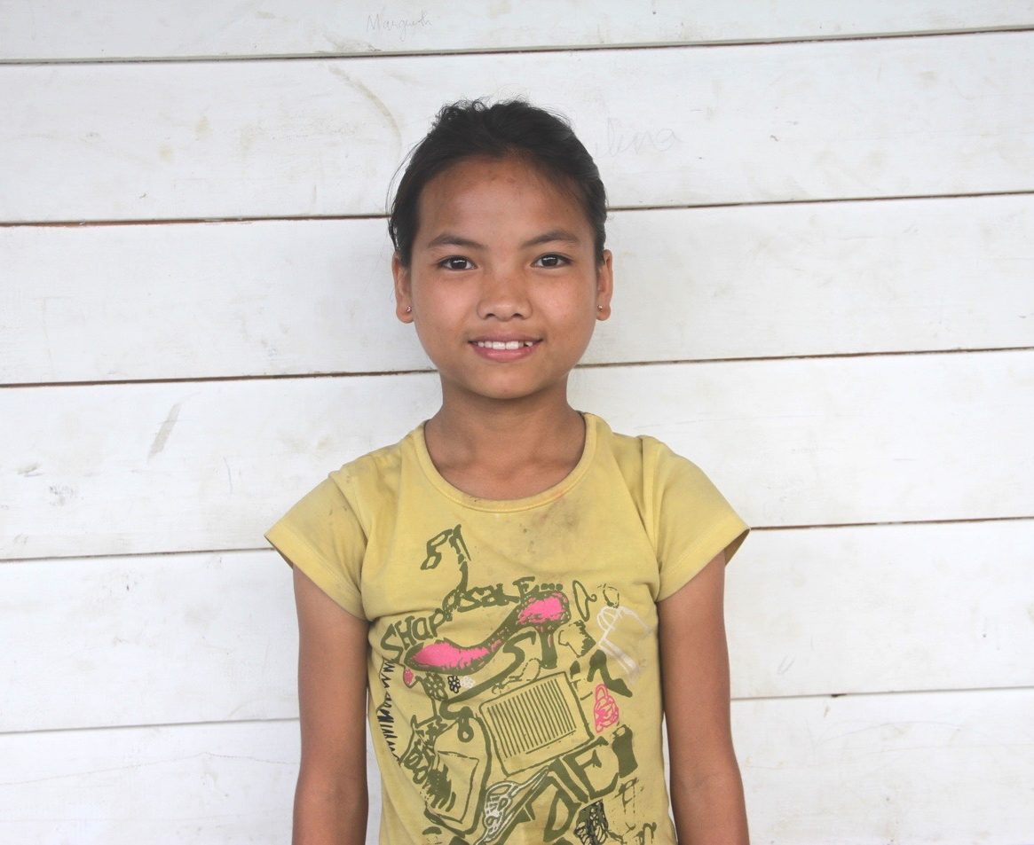

Neng is the daughter of late thangminlal chongloi. She is from a remote village c. kholen, kangpokpi district, Manipur. She is from a very poor family. She has four sisters. Her father passed away in 2014. Agriculture was their main source of income. Her mother returned to her paternal home after her husband passed away.
Since her grandparents struggles to take care of all their granddaughters, she was brought to Stephanos Children Home in February 2016. Her hobby is singing and her aim in life is to become a Nurse.

