FROM: STEPHANOS CHILDREN HOME, INDIA
NAME: NENGNEIHOI CHONGLOI
DATE OF BIRTH: 3RD OCTOBER 2007
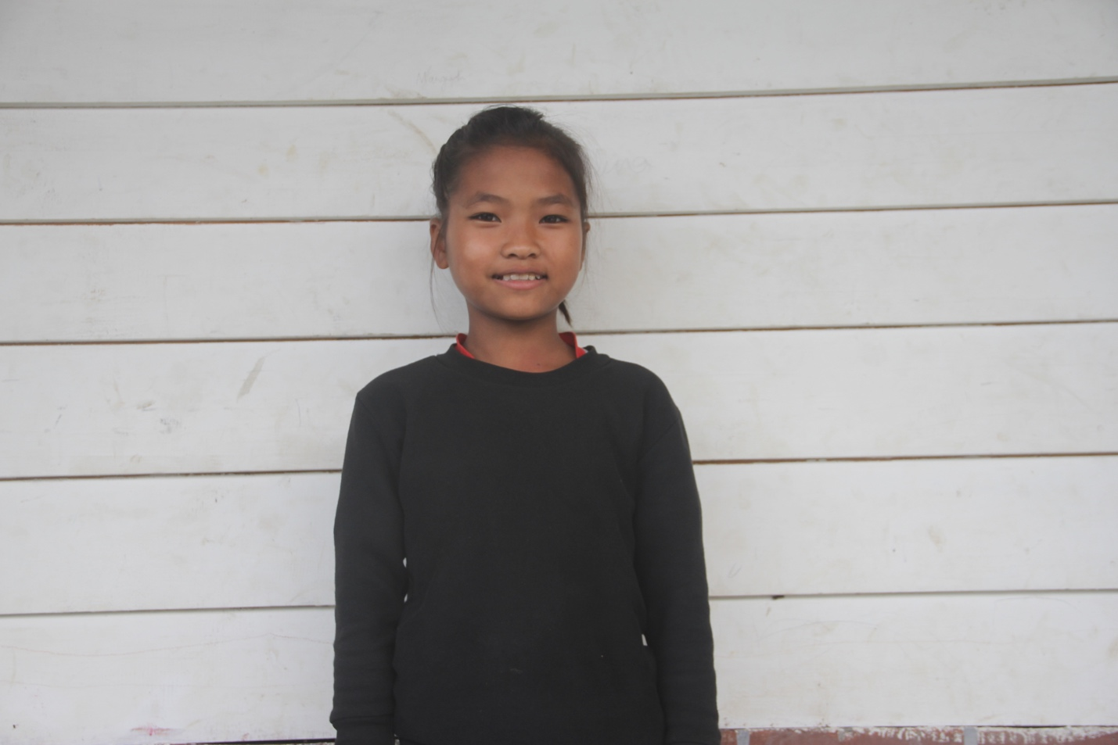

Hoi is the 2nd daughter among the sixth siblings. Her mother died of heart attack on the 15th October 2013 at RIMS Hospital, Imphal. She has four brothers and one sister. Her father earned their livelihood by working in the field. He has no other means and unable to sent them to school. On the 25th January 2016 she was brought to the home by her father for a better education and life. Her hobby is reading and her aim in life is to become a Nurse. She needs your love & support.

