FROM : STEPHANOS CHILDREN HOME, INDIA
NAME : Joshua Letjanel Chongloi
DATE OF BIRTH/AGE : 1st Jan 2012
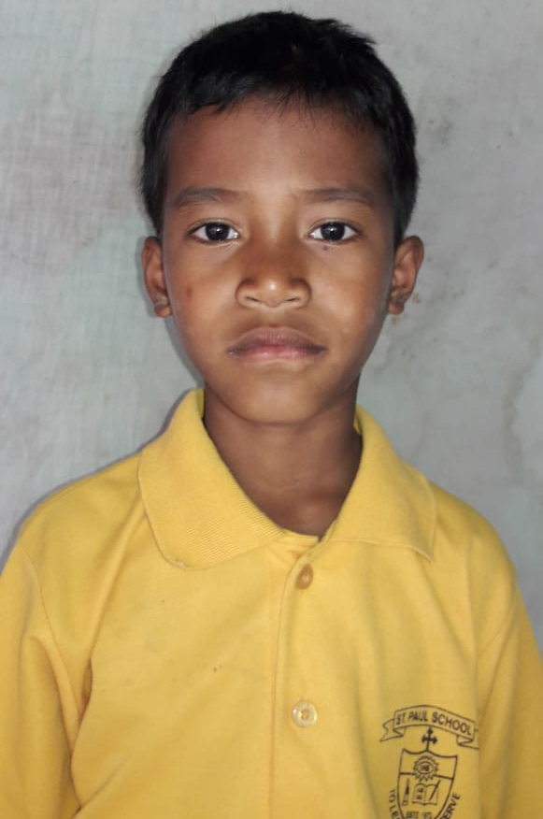
Joshua hails from a village called H. Khopibung in Manipur, India. He is the eldest son of the three siblings. He is hardworking, humorous and loves to study. His father passed away on 3rd feb 2020 due to his bad health. His parents are cultivator by profession and owing to their poor family condition his single mother couldn’t afford to make both ends meet. To get a good education was a dream to be fulfilled. As it gets harder for him to continue his studies and under constant requests and prayers, he was brought to Stephanos Children home on 2nd feb 2020. His hobby is playing Football and his aim in life is to become an IPS officer.

