FROM: STEPHANOS CHILDREN HOME, INDIA
NAME: KHOLNEICHING GUITE
DATE OF BIRTH: 1ST MAY 2009
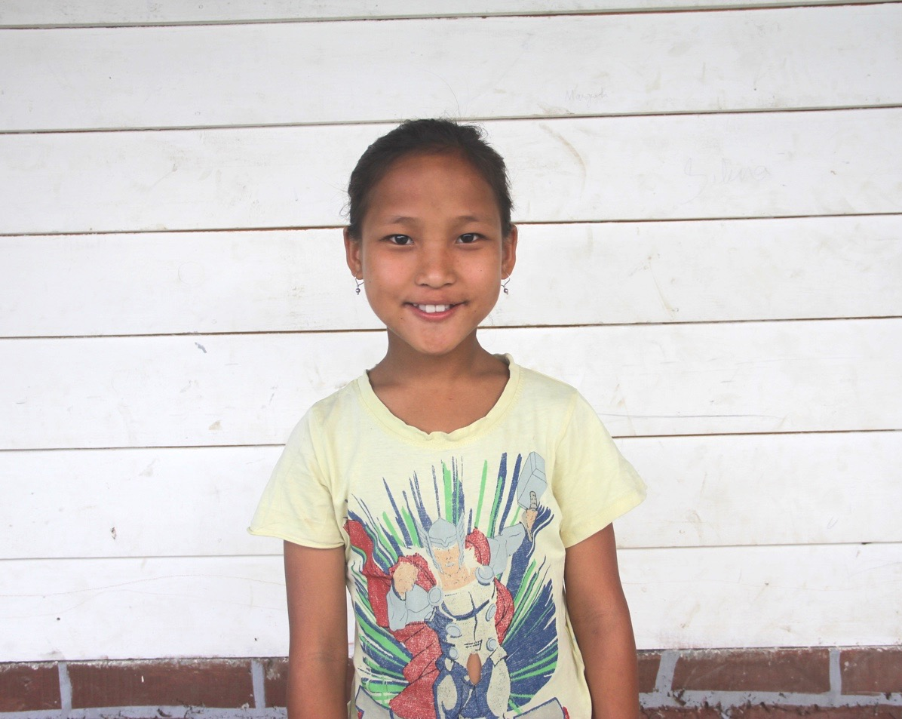

Ching is the younger sister of Hathoichong Guite. Her father is an alchoholic and a drug addict and he became abnormal and ruined all his relationship with his wife. Her mother went back to her parental home and remarried. She was raised and brought up by her grandmother. Her grandmother who is too old to raise her granddaughter has no option but begged the Stephanos Children Home to raise her granddaughter. She was brought to the home in 2012. Her hobby is Dancing and her aim in life is to become a Doctor. She needs your love & support.

