FROM: STEPHANOS CHILDREN HOME, INDIA
NAME: LALMINLUN HANGSHING
DATE OF BIRTH: 14TH JULY 2010
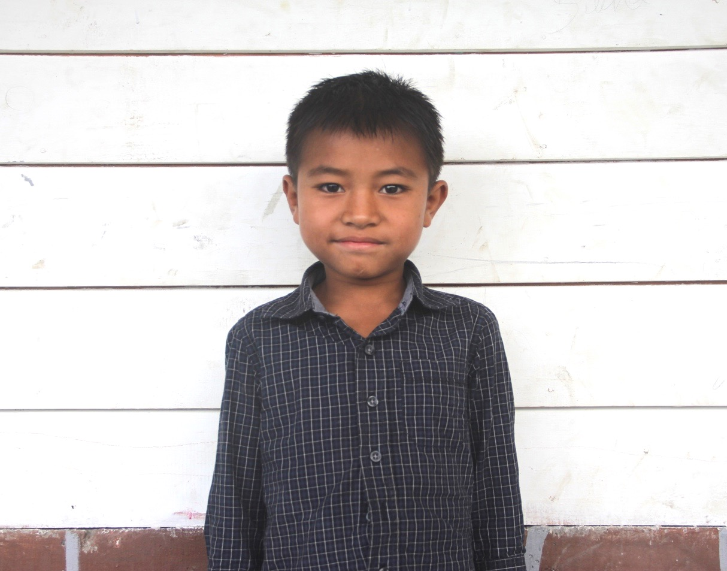

Lun is the 15th son of Late Paolenmang Hangshing. He has five brothers. His father died on the 10th October 2012, in an accident in water pump house. His mother has no income and she had to support her children in her daily wages. Since his mother could not support him with her mere income, she requested the Stephanos Children Home to take care of her son and he was brought to the home for a better and brighter future. His hobby is drawing and his aim in life is to become an Army officer. He needs your love & support.

