FROM: BLUE HAVEN HOME, LUCKNOW, INDIA
NAME: JITENDRA SINGH
DATE OF BIRTH: 31st DEC 1999
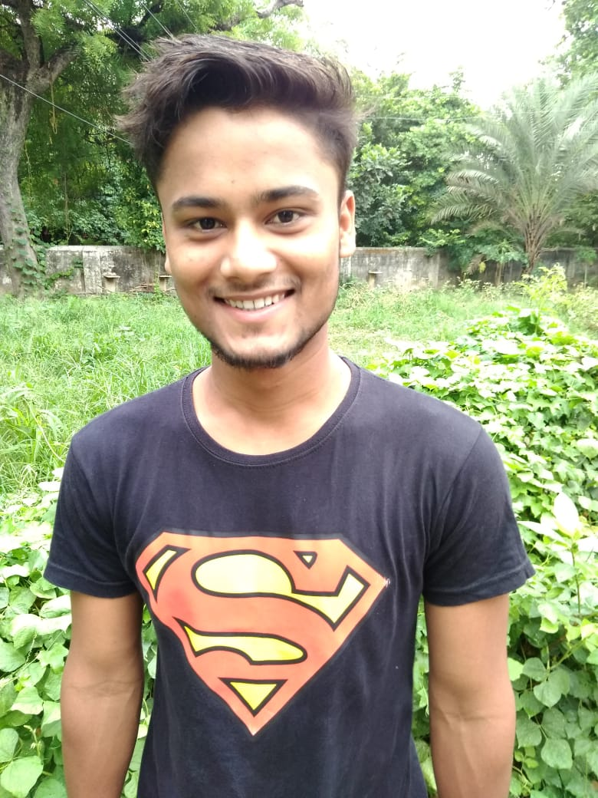

Jitendra is from Agra, India. He has 4 siblings and he is the youngest of the four. His father is retired and his mother is a housewife. They are at their old age and cannot earn or work to pay for his education. He was brought to Blue Haven because his parents wanted to give him a better education and they cannot support him because they are getting old. He was brought to Blue Haven in July 25^{th,} 2008. Currently he is studying B.com Honors. His hobby is playing music. His aim in life is to become a chartered Accountant. He needs your love & support so that he can build a proper foundation for himself so that he can help others after he has a job. The cost for 1st level for his college is R.s. 43,000 which include coaching, exam and his basic needs.

