FROM: BLUE HAVEN HOME, LUCKNOW, INDIA
N AME: RUTH
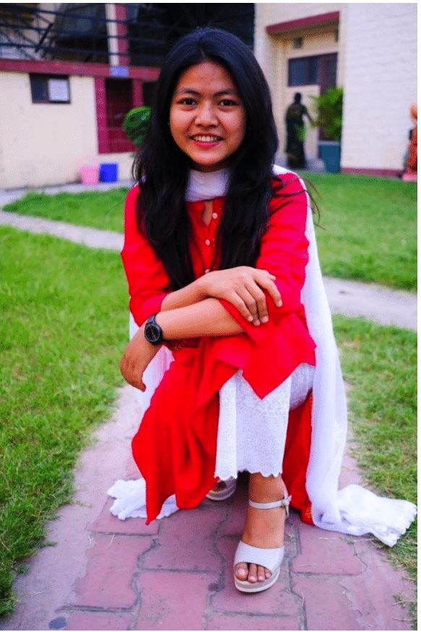
DATE OF BIRTH: 18-02-2001

This is Ruth from Blue Haven Children's Home, Lucknow India. She is currently pursuing Nursing school with the help of your prayers and support.
She has finished her first year and she will need to continue with the second year of Nursing School. She needs help with paying for her college fees which costs $1344 for the second year. We pray the Lord will use you to help with this need so that Ruth can continue her studies in the hope of a brighter future.
If the Lord is leading you to help with this need then, please listen to the Lord's call by giving or donating.

Thank you & God bless!

