FROM: STEPHANOS HOME, INDIA
NAME: LAMMINSEI LHOUVUM
DATE OF BIRTH: 28TH SEPT 2011
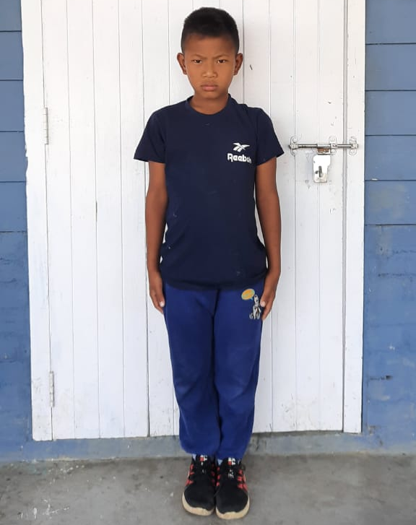

Lamminsei has 1 elder sister and 2 elder brothers. His father passed away in the year 2018. His mother remarried leaving all her children behind.
His eldest brother tried his best to care for his sibling needs but since he cannot support them financially, he was brought to Stephanos home in hope for a better future educationally, mentally, physically and spiritually.

