FROM: STEPHANOS CHILDREN HOME, INDIA
NAME: NENGJALAM GUITE
DATE OF BIRTH: 5TH OCTOBER 2006
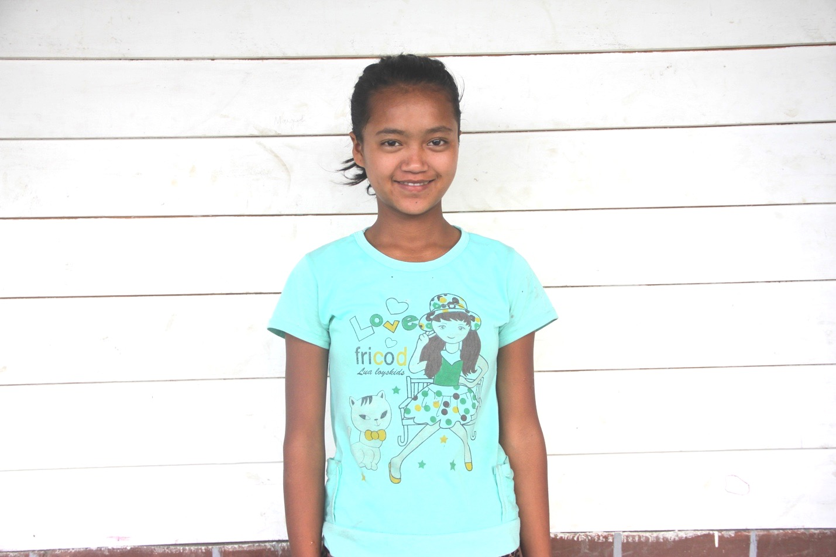

Neng is the oldest daughter of Late Ngamkhojam Guite. She has two brothers and two sisters. After the death of her father and mother she is under the foster care of her grandparents. However, her grandparents are below poverty line. They are unable to support for her education and daily needs. So, they brought her to Stephanos Children Home in February 2016. Her hobby is singing and her aim in life is to become a Nurse. She needs your love & support.

