FROM: BETHESDA NURSING COLLEGE, MANIPUR
N AME: Ralsiemtling Intoate
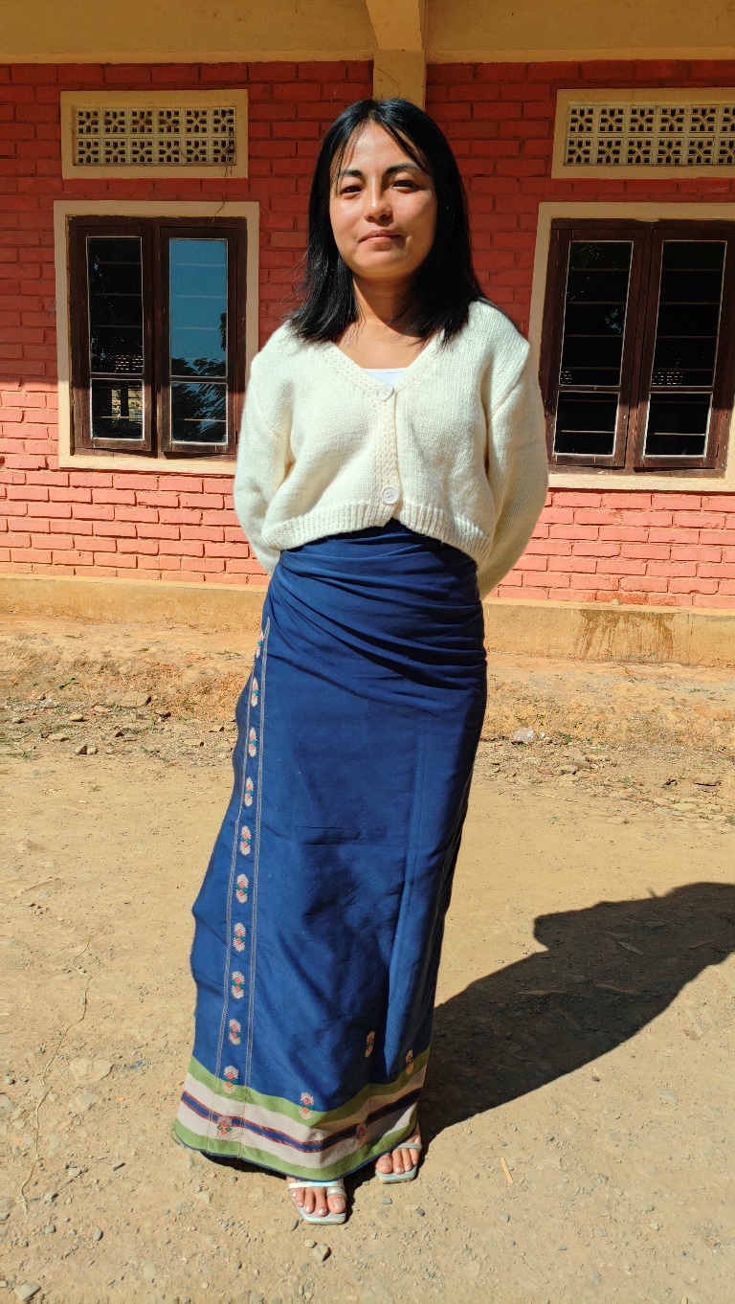
DATE OF BIRTH: 30-03-2002

Ralsiemtling alias Rali comes from a village in Assam the neighbouring state of Manipur. She has 2 sisters and 2 brothers.Her father passed away in 2015 when Rali was 13yrs old. Her mother has no regular income . She earn from selling cook meat and vegetable door to door and that is not very stable.
Now Rali is doing her Bsc Nursing 2nd year in Bethesda College of Nursing. At the beginning her sister who is working as a missionary supported her by taking a loan. But she could hardly clear the loan from her smal honorrorium. They are helpless now as to how to continue for the next year.
If any one can help her to finish her course. As her mother's health is also getting weak .

