FROM: STEPHANOS CHILDREN HOME, INDIA
NAME: TINGNEINEM KHONGSAI
DATE OF BIRTH: 4TH MAY, 2005
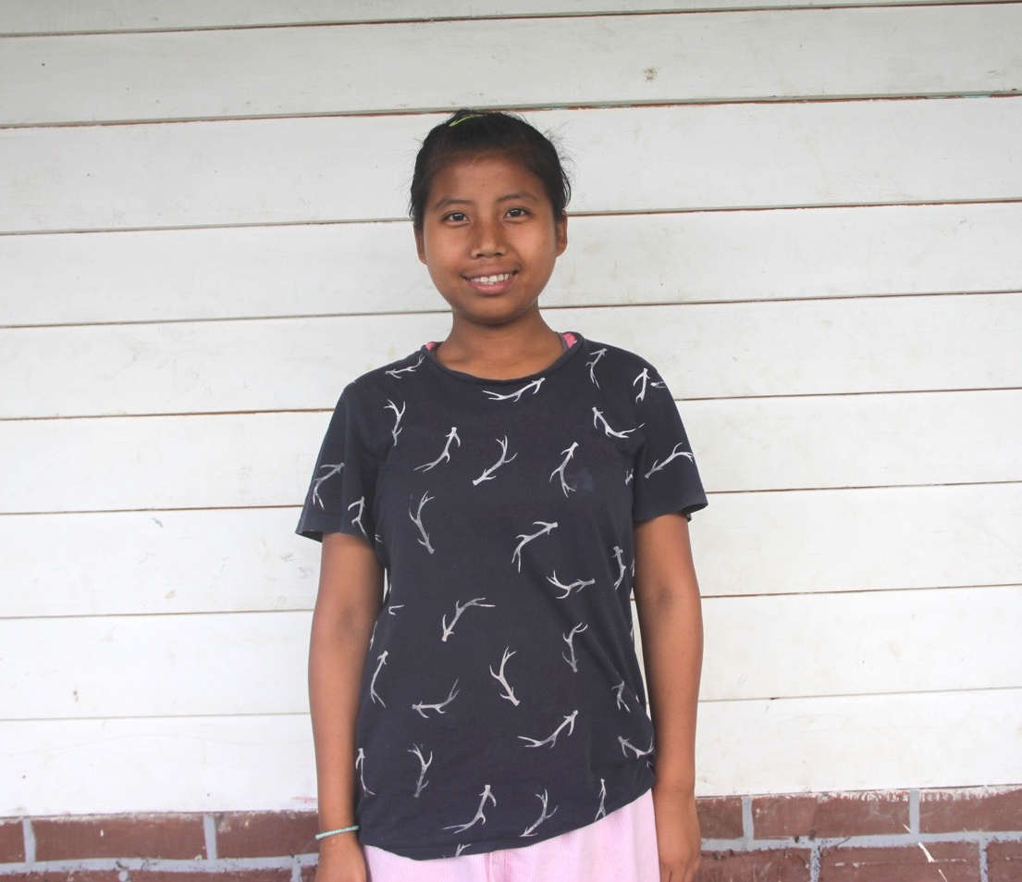

Ting is from a remote village L. Molnom in Ukhrul District eastern part of Manipur. She has four sisters and one brother. Her father and her only brother died together at the same time due to same sickness i.e. Malaria epidemic. Her mother with grief and broken heart, encourage herself, tried her best to bring up the entire sibling that were left behind by her beloved husband. It was difficult for a widow to maintain all the family expenses and sent them all to school. Therefore, seeing all her grievances and difficulties one of her daughters (Ting) has been put in Stephanos Children Home. Her hobbies are singing, cooking and reading novels. Her aim in life is to become a Doctor. She needs your love & support.

